Report on the ELIXIR Preparatory Phase
This is a report on the Preparatory Phase of the ELXIR Research Infrastructure, and the implications of these developments for infrastructures in plant genomic sciences, prepared for the transPLANT project (http://www.transplantdb.eu).
- ELIXIR and the Roadmap for European Research Infrastructures
The purpose of ELIXIR (http://www.elixir-europe.org/) is to construct and operate a sustainable infrastructure for biological information in Europe to support life science research and its translation to medicine and the environment, the bio-industries and society. ELIXIR is funded as a Research Infrastructure (RI) by the European Commission (EC), as part of the ESFRI programme. ESFRI (http://ec.europa.eu/research/infrastructures/index_en.cfm?pg=esfri ), the European Strategy Forum on Research Infrastructures, is a strategic instrument to develop the scientific integration of Europe and to strengthen its international outreach. The competitive and open access to high quality Research Infrastructures supports and benchmarks the quality of the activities of European scientists, and attracts the best researchers from around the world. ELIXIR has been identified as a critical RI of global significance, and through the related project BioMed Bridges (http://www.biomedbridges.eu/), which is jointly coordinated with ELIXIR, brings together the ESFRI Research Infrastructures in the Bio Medical Sciences field. However, the scope of ELIXIR is broader, covering all applications of life science data, including those outwith the medical field.
- ELIXIR preparatory phase and the ELIXR Business Case
The need for ELIXIR has been agreed upon by a preparatory phase consortium including representatives from 11 European countries, including all of Europe’s largest economies. Members of this consortium included institutes with a leading role in data-driven biology; funding bodies; and commercial organisations. The consortium was coordinated by the European Molecular Biology Laboratory (EMBL), which runs the European Bioinformatics Institute (EBI), Europe’s leading centre for the provision of bioinformatics services. The product of the preparatory phase was a full business case for subsequent construction, which is available for download (http://www.elixir-europe.org/sites/elixir-europe.org/files/documents/businesscase_2011_high_res.pdf).
The document’s argument can be summarised as follows: (i) (biomolecular) data is of increasing importance and quality in biological research (ii) resources currently spent on archiving, interpreting and making available that data are an extremely small fraction of the resources spent on generating it (iii) there are strong ethical, economic and scientific reasons for exposing this data under an open-access model (iv) international coordination of infrastructure development is currently insufficient. The main route through which international coordination does occur is through the funding of EMBL via 20 national governments; but as the volume and variety of data continues to grow, the challenge exceeds what one organisation (or country) could address. As data (and efforts to organise it) become increasingly distributed, it is essential that action is taken to reduce fragmentation and redundancy of efforts.
- The ELIXIR model

In addition to demonstrating the need for ELIXIR, the Business Case document also proposes a framework for its implementation, the core components of which are as follows:
- Data delivery from a European Data Centre, to be managed by EBI. EBI already develops many of the core informatics resources for life science researchers (e.g. archives for many of the most important data types), and ELIXIR will fund their dissemination and tighter integration with the more specialist resources under development at the national level.
- Technical coordination though the establishment (by EBI) of data registries and standards, allowing ELIXIR nodes (nationally funded centres with foci on specific domains) to interact with the data centre and support seamless inter-operability from the user perspective. The goal is to provide users with a connected network of resources, constructed from expertise and data distributed across Europe. Many of these nodes will be national centres, coordinating data and activities in particular countries (e.g. data with confidential aspects which cannot be easily transmitted over national boarders) and providing the appropriate interfaces for the portion of the data that can be publicly shared.
Figure 1: The Elixir model
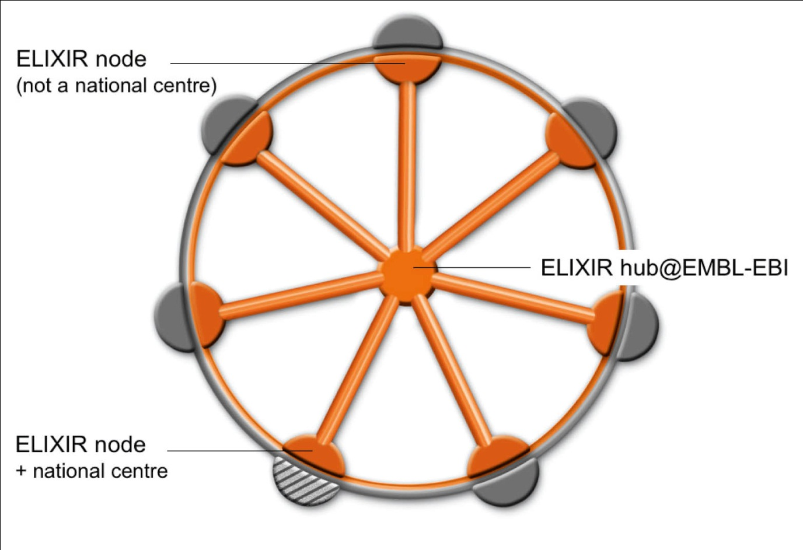
- The provision by hub and nodes of compute infrastructure. Distributed compute infrastructure (i.e. close to the data) will become increasingly important as data volumes grow.
- Close interaction with other ESFRI initiatives in the biomedical sciences
- Coordination of user training activities to ensure pan-European access to the distributed resource.
- Services provides by the nodes will include some or all of the following: data resources, compute provision, training, tools, standards. Nodes must be capable of providing internationally competitive services at the pan-European level. Node applicants will need to demonstrate sustainability of funding.
- The establishment of ELIXIR as a legal entity. Countries will apply to join ELIXIR; nodes must be provided or represented by a member country. An ELXIR management structure will be established by EBI, answerable to a board consisting of the member states.
- A Scientific Advisory Board (SAB) will be established, and (among other duties) will review node applications. The SAB will report to the full board of ELIXIR, i.e. indepdently of EBI.

- Expressions of Interest
In a preliminary exercise conducted during the preparatory phase, 57 highly varied expressions of interest in assuming node status were submitted from institutions in 24 different countries; the actual applications are awaited with interest. 4 applications in particular focused on plant/agromonic science, led by the University of Padvoa (Italy); the Laboratory Associado de Oerias (Portugal), Rothamstead Research (UK) and The Centre for Genome Analysis (UK). TGAC are currently partners in transPLANT, as is EBI (the proposed operator of the EXLIR hub).
- Next steps
A construction phase for the construction of the research infrastructure is now underway. A Memorandum of Understanding (MoU) has been drawn up for countries wishing to contribute to the construction phase. The construction phase commenced with the signature of 5 countries and is limited in duration to 24 months. 13 countries have currently signed the MoU. The SAB has been appointed and a Founding Director is now being sought. The process of node selection is currently underway in the individual counties, to be reviewed by the SAB in late 2012/early 2013
Figure 2. Process for Node Applications
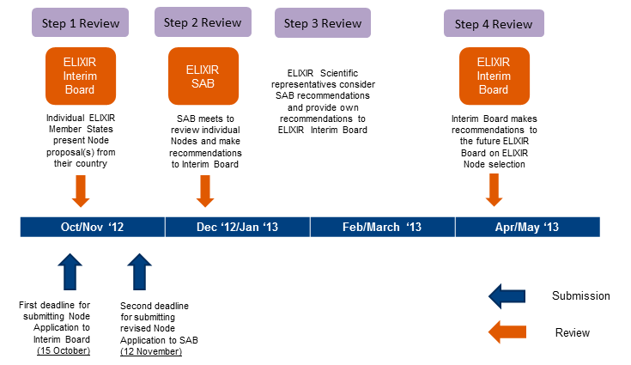
- Funding
Funding for the construction of a European Data Centre to host the ELIXIR hub, located alongside the existing buildings of the EBI, has been secured from the Biology and Biotechnology Research Council of the United Kingdom. Full funding, for the nodes and for the coordinating activities of the hub, has not yet been secured. It is expected that ELIXIR will begin operating on a pilot basis, with only a few nodes working in collaboration with the hub. It is hoped that the infrastructure will be fully functional within 5 years.
- ELIXIR and EC infrastructure funding.
As noted, ELIXIR will provide for the funding of national nodes, a trans-national hub, and for cooperation between them. It will not directly replace the collaboration of institutes and companies across Europe in coordination, service, and RTD activities (such as are funded through the I3 grants available under the existing Framework 7 programme, and of which transPLANT is one). Although it is possible that, to some extent, the function of such infrastructures might be partially replaced by ELIXIR, it is also likely that there will continue to be a strong case for institutions in particular domains interacting across national boundaries; and that ELIXIR nodes will be active participants in specific I3 project relevant to their domains, providing trans-national connections between the ELIXIR infrastructure and individual centres of excellence across Europe.
---
For more information about ELIXIR please contact the ELIXIR project office on elixirpm@ebi.ac.uk; about transPLANT, please contact the project coordinator Dr. Paul Kersey on pkersey@ebi.ac.uk.
---
The transPLANT project is funded by the European Commission within its 7th Framework Programme under the thematic area "Infrastructures", contract number 283496.

