transPLANT milestone report
MS24 (work package 10): A Basic GWAS GUI available
GMI, as project lead, has developed GWAPP, a web-application (http://gwas.gmi.oeaw.ac.at) that allows researches to run Genome Wide Association Mapping (GWAS) on any Arabidopsis thaliana phenotype in “real-time”.
The user only has to provide the phenotype (as a comma separated file) and select the appropriate method (mixed model, linear model, non-parametric test). The analysis is automatically run on the server. Once the analysis is finished the results are presented to the user with interactive Manhattan plots. Users can zoom in and display a gene annotation aligned to the Manhattan charts and also visualize linkage disequilibrium (LD) structure.
In addition to standard GWAS method GWAPP also allows the user to run conditional GWAS by adding one or more SNPs as co-factors to the analysis.
GWAPP has been developed using modern web-technologies and an emphasis was put on ease of use and performance. According to the Google Analytics statistics GWAPP has a fair number of users from all over the world. The source code is open source (https://github.com/timeu/GWAPP) and there is also a preinstalled preconfigured Virtual machine (VM) image (https://cynin.gmi.oeaw.ac.at/home/resources/gwapp/gwapp) available. The VM image can be deployed on either on-premise/private cloud our public cloud services. GWAPP was published in The Plant Cell in December 2012: Seren, et. al. (2012) GWAPP: A Web Application for Genome-Wide Association Mapping in Arabidopsis

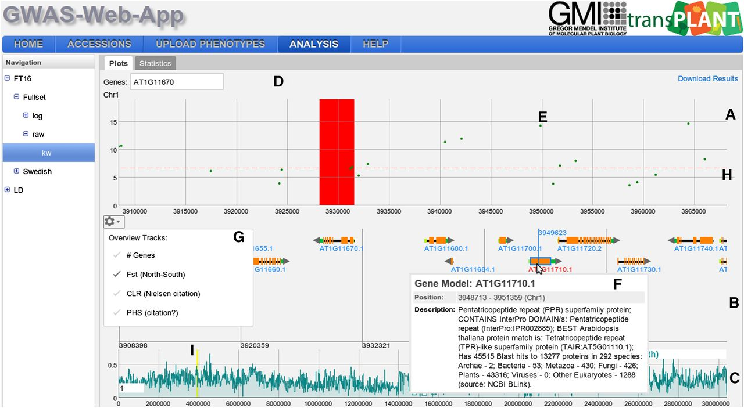
Figure 1 – Interactive Manhattan plots

