transPLANT milestone report
MS1 (work package 1): Internal project website
The internal project website has been established using core facilities available at the EMBL-EBI. Specifically, we created a dedicated ‘transPLANT space’ within the EBI’s Confluence wiki system [1]. This private site has been made available to project partners and collaborators by creating user accounts with read a write access to the transPLANT space. The Confluence wiki system provides a rich set of functionality [2], allowing all users to search and collaborate on project documentation, maintaining the history of edited content, allowing comments to be added and various types of automatic notifications to be configured. Importantly, the site allows various types of documents and images to be attached to pages. The figure below shows the current transPLANT project homepage in the Confluence system.
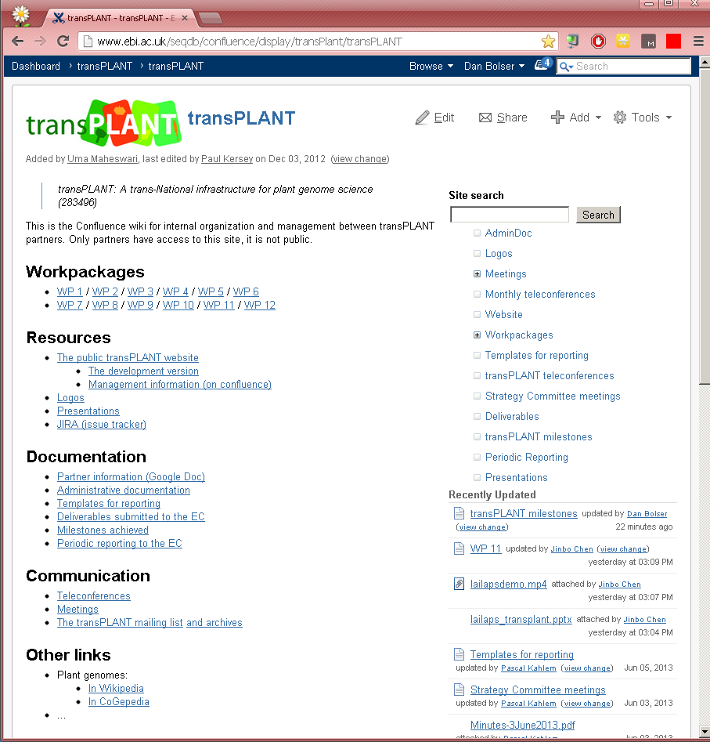

- http://www.ebi.ac.uk/seqdb/confluence/display/transPlant/transPLANT
- http://www.atlassian.com/software/confluence/overview/team-collaboration-software

